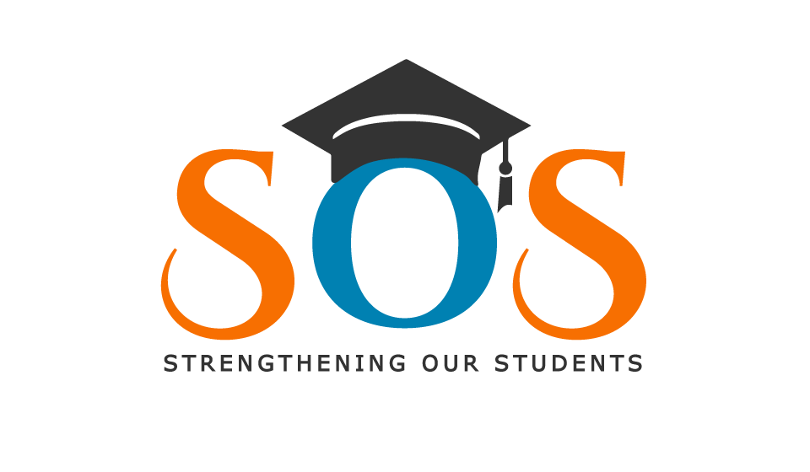
Sponsorship Package for SOS: Strengthening Our Students
Saturday, February 24, 2024, SOS: Strengthening Our Students will celebrate the 11th Annual “Soup 4 the Soul” Fundraiser from 2 p.m. until 5 p.m. Hilton Garden Inn, 700 Beta Drive Mayfield Village, Ohio 44143.
The event will be hosted by Fox 8 News “Kickin it With Kenny” Kenny Crumpton. Celebrity servers scheduled to appear; Fox 8 News, WKYC Channel 3, News Channel 5, WOIO Cleveland19 News, CW43 Focus, 93.1 FM WZAK, Sam Sylk. Jay Honda Auto Group, Mark Lyons and Nate Lancry. Skye La Rae’s Culinary Service, Eric Wells, Hope Haven, Yvonne Pointer. Chill Talk host, Kevin “Chill” Heard. WKNR 850am. WOVU 95.9 FM.
“Soup 4 the Soul” is an opportunity for the community to sample deliciously prepared soups. After the feast get your praise on with a live concert. Last year’s event sold out. There will be door prizes, raffle, silent auction, vendors, and more…
SOS: Strengthening Our Students is a 501c3 non-profit organization whose mission is to enrich the lives of family and children through education, life skills, and innovative programs, such as; Young Entrepreneur Program, and Summer Camp. All proceeds benefit SOS.
Pre-sale tickets $35.00 will be available starting November 1, 2023 online www.strengtheningourstudents.com Click “Donate”
Donations $40.00 dollars at the door day of event.
For more information about Sponsorship Package, contact Event Chair Richard Scott 216.374.6452 or Executive Director Dyeatra Williams 216.321.0911.
Visit Our Website: strengtheningourstudents.com
Like us on Facebook, Twitter, Instagram, YouTube

Presenting Sponsorship Marketing Strategy for 2024
- Print
- Your company name/logo will appear in every print advertisement/editorial as Presenting sponsor.
- * The Plain Dealer *Call & Post * Cleveland.com * Code M Magazine

- Electronic Media
- Television
- Radio
- Social Media (Facebook, Facebook Live, Twitter, Instagram)
- Website
- Video Streaming

- Promotional Items
- Your company name/logo will appear on all promotional items include: Posters/Flyers/Banners/Souvenir Program

- Event Your company name/logo will appear via video streaming throughout the event as a Presenting sponsor
- Your company name/logo will be mentioned continuously throughout the evening as a Presenting sponsor
- Your company will receive ten (10) complimentary event tickets
- Commemorative “Soup 4 the Soul” Apron

Presenting Sponsorship Investment: $10,000

Gold Sponsorship Marketing Strategy for 2024
- Promotional Items
- Your company name/logo will appear on all promotional items include: Posters/Flyers/Banners/Souvenir Program

- Electronic Media
- Television
- Radio
- Social Media (Facebook, Facebook Live, Twitter, Instagram)
- Website
- Video Streaming

- Event
- Your company name/logo will appear via video streaming throughout the event as a Gold sponsor
- Your company name/logo will be mentioned continuously throughout the evening as a Gold sponsor
- Your company will receive eight (8) complimentary event tickets
- Commemorative “Soup 4 the Soul” Apron

Gold Sponsorship Investment: $5,000

Silver Sponsorship Marketing Strategy for 2024

- Promotional Items
- Your company name/logo will appear on all promotional items include: Posters/Flyers/Souvenir Program

- Electronic Media
- Television
- Radio
- Social Media (Facebook, Facebook Live, Twitter, Instagram)
- Website

- Event
- Your company name/logo will be mentioned continuously throughout the evening as a Silver sponsor
- Your company will receive six (6) complimentary event tickets
- Commemorative “Soup 4 the Soul” Apron

Silver Sponsorship Investment: $3,000

Bronze Sponsorship Marketing Strategy for 2024

- Promotional Items
- Your company name/logo will appear on all promotional items include: Posters/Flyers/Souvenir Program

- Electronic Media
- Television
- Radio
- Social Media (Facebook, Facebook Live, Twitter, Instagram)
- Website

- Event
- Your company name/logo will be mentioned continuously throughout the evening as a Bronze sponsor
- Your company will receive four (4) complimentary event tickets
- Commemorative “Soup 4 the Soul” Apron

Bronze Sponsorship Investment: $2,000

